Vernacular Names: Ipil | Scientific Name: Intsia bijuga (Colebr.) O.Ktze
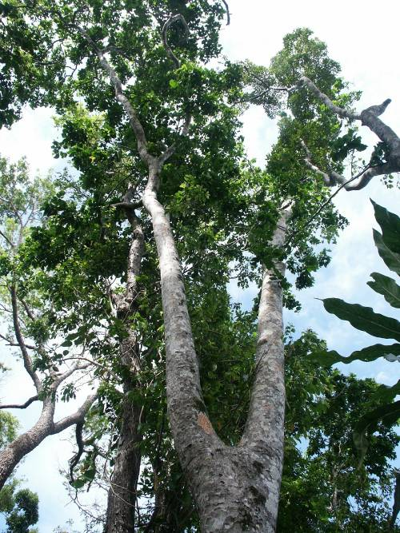 | 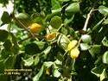  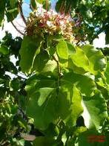
Full tree form | Details of leaf, flower, & fruit
Native or Introduced: Native

Description: Intsia bijuga is a medium-sized tree of up to 35-(50) m in height. Mature trees have steep rounded buttresses. The trunk can be crooked or straight but the crown is usually spreading and branchlets are smooth. The leaves are divided into 1-6 leaflets, varying in shape from broadly oval to quite narrow. Flowers are white or pink and arranged in dense heads. The fruit pod is oblong or pear shaped, and woody, usually containing 1-9 seeds.

Habitat: It is often found on sand and coral beaches, but also features in periodically inundated localities further inland. It also occurs in dry land mangroves (Lumnitzera) which can be the final stage of mangrove forest succession and the transition to inland forests. Good stands at East Point Plantation on DG, and planted ornamentally “downtown”.

Human uses: The tree's timber is a very durable and termite-resistant wood, making it a highly valued material for flooring and other uses. The wood can also be used to extract a dye. The bark and leaves of the ipil are used in traditional medicines. The wood Merbau can contain a "gold" fleck that runs through the grain, considered to be attractive by some. The wood is used for flooring in U.S. and European markets where it is commonly sold under different names.

Significance: Due to extensive logging of the tree, it is endangered in many places in Southeast Asia, and almost extinct in some. Extensive amounts were purchased for the venue of the 2008 Summer Olympics in China, which is the largest importer of the wood.

Propagation: Seed may be sown directly in the field. Propagation of bare root seedlings is popular, although stump cuttings have also been successfully used. Natural regeneration from fallen seed is good in over logged areas.

